Northwood Falcon Volleyball Fan Wear Order
Directions: Next to the size of the item you want, write the amount of that item you would like.
Orders are due by AUGUST 17th, in hopes to get the items by our first playing date. ***They may not arrive prior to our first scrimmage.
Please extend the orders to friends, family, teachers and the NHS Community.

Additional Pricing
2XL -add $1; 3XL add $2, 4XL add $3

Make checks payable to Northwood Volleyball

NAME__________________________________ Phone ____________________

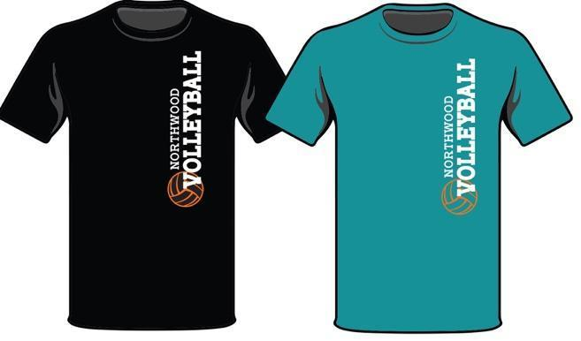
A. NHS Volleyball Fan Wear $10
 | YXS | YS | YM | YL | AS | AM | AL | AXL | 2XL | 3XL
Black
Jade

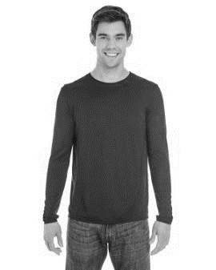
B. Black - Performance T-Shirt
(men's long sleeve) $14
XS | S | M | L | XL | 2X | 3X

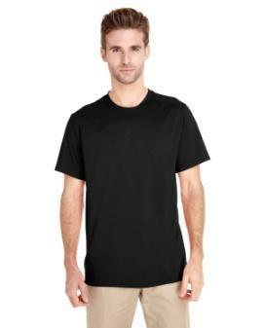
C. Black - Performance T-Shirt (men's short sleeve) $12.50
XS | S | M | L | XL | 2X | 3X

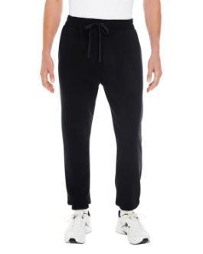
D. Black - sweats (men's sizes) $25
S | M | L | XL | 2X | 3X

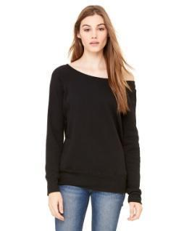
F. Black - Crew Neck Sweatshirt (women's sizes) $25
S | M | L | XL | 2X

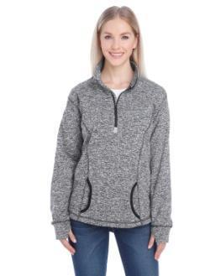
E. Charcoal & Black - 1/4 zip sweatshirt (women's sizes) with Embroidery $27
S | M | L | XL | 2X | 3X

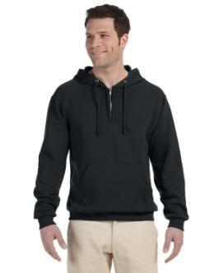
G. Black - 1/4 zip sweatshirt with hood (men's sizes) $24
S | M | L | XL | 2X | 3X

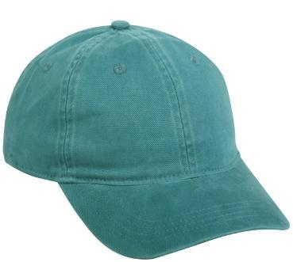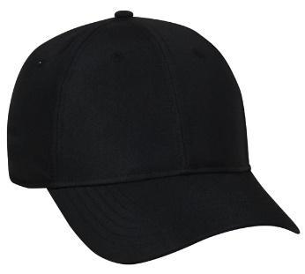
H. $14 – with embroidery I. $15 – with embroidery
Quantity: _________ Quantity: __________
**All Designs are made by NStyle Designs

Athlete’s Name: ______________________________________________
NAME | ORDER  Additional Pricing  2XL -add $1; 3XL add $2, 4XL add $3 |  |  |  |  |  |  |  |  |  | TOTAL ($)
 | A |  | B | C | D | E | F | G | H | I
 | BLACK  YS-  YM-  YL-  AS-  AM-  AL-  XL-  2X-  3X- | JADE  YS-  YM-  YL-  AS-  AM-  AL-  XL-  2X-  3X- | XS-  S-  M-  L-  XL-  2X-  3X- | XS-  S-  M-  L-  XL-  2X-  3X- | S-  M-  L-  XL-  2X-  3X- | S-  M-  L-  XL-  2X-  3X- | S-  M-  L-  XL-  2X- | S-  M-  L-  XL-  2X-  3X-
 | BLACK  YS-  YM-  YL-  AS-  AM-  AL-  XL-  2X-  3X- | JADE  YS-  YM-  YL-  AS-  AM-  AL-  XL-  2X-  3X- | XS-  S-  M-  L-  XL-  2X-  3X- | XS-  S-  M-  L-  XL-  2X-  3X- | S-  M-  L-  XL-  2X-  3X- | S-  M-  L-  XL-  2X-  3X- | S-  M-  L-  XL-  2X- | S-  M-  L-  XL-  2X-  3X-
 | BLACK  YS-  YM-  YL-  AS-  AM-  AL-  XL-  2X-  3X- | JADE  YS-  YM-  YL-  AS-  AM-  AL-  XL-  2X-  3X- | XS-  S-  M-  L-  XL-  2X-  3X- | XS-  S-  M-  L-  XL-  2X-  3X- | S-  M-  L-  XL-  2X-  3X- | S-  M-  L-  XL-  2X-  3X- | S-  M-  L-  XL-  2X- | S-  M-  L-  XL-  2X-  3X-
 | BLACK  YS-  YM-  YL-  AS-  AM-  AL-  XL-  2X-  3X- | JADE  YS-  YM-  YL-  AS-  AM-  AL-  XL-  2X-  3X- | XS-  S-  M-  L-  XL-  2X-  3X- | XS-  S-  M-  L-  XL-  2X-  3X- | S-  M-  L-  XL-  2X-  3X- | S-  M-  L-  XL-  2X-  3X- | S-  M-  L-  XL-  2X- | S-  M-  L-  XL-  2X-  3X-
Athlete’s Name: ______________________________________________
NAME | ORDER  Additional Pricing  2XL -add $1; 3XL add $2, 4XL add $3 |  |  |  |  |  |  |  |  |  | TOTAL ($)
 | A |  | B | C | D | E | F | G | H | I
 | BLACK  YS-  YM-  YL-  AS-  AM-  AL-  XL-  2X-  3X- | JADE  YS-  YM-  YL-  AS-  AM-  AL-  XL-  2X-  3X- | XS-  S-  M-  L-  XL-  2X-  3X- | XS-  S-  M-  L-  XL-  2X-  3X- | S-  M-  L-  XL-  2X-  3X- | S-  M-  L-  XL-  2X-  3X- | S-  M-  L-  XL-  2X- | S-  M-  L-  XL-  2X-  3X-
 | BLACK  YS-  YM-  YL-  AS-  AM-  AL-  XL-  2X-  3X- | JADE  YS-  YM-  YL-  AS-  AM-  AL-  XL-  2X-  3X- | XS-  S-  M-  L-  XL-  2X-  3X- | XS-  S-  M-  L-  XL-  2X-  3X- | S-  M-  L-  XL-  2X-  3X- | S-  M-  L-  XL-  2X-  3X- | S-  M-  L-  XL-  2X- | S-  M-  L-  XL-  2X-  3X-
 | BLACK  YS-  YM-  YL-  AS-  AM-  AL-  XL-  2X-  3X- | JADE  YS-  YM-  YL-  AS-  AM-  AL-  XL-  2X-  3X- | XS-  S-  M-  L-  XL-  2X-  3X- | XS-  S-  M-  L-  XL-  2X-  3X- | S-  M-  L-  XL-  2X-  3X- | S-  M-  L-  XL-  2X-  3X- | S-  M-  L-  XL-  2X- | S-  M-  L-  XL-  2X-  3X-
 | BLACK  YS-  YM-  YL-  AS-  AM-  AL-  XL-  2X-  3X- | JADE  YS-  YM-  YL-  AS-  AM-  AL-  XL-  2X-  3X- | XS-  S-  M-  L-  XL-  2X-  3X- | XS-  S-  M-  L-  XL-  2X-  3X- | S-  M-  L-  XL-  2X-  3X- | S-  M-  L-  XL-  2X-  3X- | S-  M-  L-  XL-  2X- | S-  M-  L-  XL-  2X-  3X-

Athlete’s Name: ______________________________________________
NAME | ORDER  Additional Pricing  2XL -add $1; 3XL add $2, 4XL add $3 |  |  |  |  |  |  |  |  |  | TOTAL ($)
 | A |  | B | C | D | E | F | G | H | I
 | BLACK  YS-  YM-  YL-  AS-  AM-  AL-  XL-  2X-  3X- | JADE  YS-  YM-  YL-  AS-  AM-  AL-  XL-  2X-  3X- | XS-  S-  M-  L-  XL-  2X-  3X- | XS-  S-  M-  L-  XL-  2X-  3X- | S-  M-  L-  XL-  2X-  3X- | S-  M-  L-  XL-  2X-  3X- | S-  M-  L-  XL-  2X- | S-  M-  L-  XL-  2X-  3X-
 | BLACK  YS-  YM-  YL-  AS-  AM-  AL-  XL-  2X-  3X- | JADE  YS-  YM-  YL-  AS-  AM-  AL-  XL-  2X-  3X- | XS-  S-  M-  L-  XL-  2X-  3X- | XS-  S-  M-  L-  XL-  2X-  3X- | S-  M-  L-  XL-  2X-  3X- | S-  M-  L-  XL-  2X-  3X- | S-  M-  L-  XL-  2X- | S-  M-  L-  XL-  2X-  3X-
 | BLACK  YS-  YM-  YL-  AS-  AM-  AL-  XL-  2X-  3X- | JADE  YS-  YM-  YL-  AS-  AM-  AL-  XL-  2X-  3X- | XS-  S-  M-  L-  XL-  2X-  3X- | XS-  S-  M-  L-  XL-  2X-  3X- | S-  M-  L-  XL-  2X-  3X- | S-  M-  L-  XL-  2X-  3X- | S-  M-  L-  XL-  2X- | S-  M-  L-  XL-  2X-  3X-
 | BLACK  YS-  YM-  YL-  AS-  AM-  AL-  XL-  2X-  3X- | JADE  YS-  YM-  YL-  AS-  AM-  AL-  XL-  2X-  3X- | XS-  S-  M-  L-  XL-  2X-  3X- | XS-  S-  M-  L-  XL-  2X-  3X- | S-  M-  L-  XL-  2X-  3X- | S-  M-  L-  XL-  2X-  3X- | S-  M-  L-  XL-  2X- | S-  M-  L-  XL-  2X-  3X-

